**EXP#4 Simulation Guidelines**

**Experiment Admin:**  **Date:**

|  |  |  |  |  |
| --- | --- | --- | --- | --- |
| **Student ID No** | **Name and Surname** | **Points** | | |
| **Q** | **Expr** | **T** |
|  |  |  |  |  |

In this experiment, you are going to test **Thevenin** and **Norton Equivalent Theorems**. Both theorems will be tested on the same circuit (Fig 4.4). In the first part of experiment, you should measure **equivalent resistance** and **voltage** for Thevenin equivalent. Then, you need to measure current of load (**RL = 1kΩ**) in the original network. Afer that, you should assemble a new circuit with Theveinin equivalent elements plus **RL = 1kΩ** load. For verification of the the theorem, you should compare both measurements. For the second part of experiment, you only need to measure **Norton equivalent current** to determine Norton Equivalent elements as its output resistance is measured in previous measurement. For the last part of experiment, you should be able to show **max power transfer resistance** for the original circuit by using its Thevenin equivalent circuit. Then, you are expected to fill out each following table. Finally, you should upload your final report for evaluation.

You need to study Lab manual[1] to get familiar with the subject. And, be prepared to run simulations on LTspice™.

**Circuit: Fig 4.4**

**Circuit elements:** R1 = 10 kΩ, R2 = 1.8 kΩ, R3 = 1.2 kΩ, R4 = 33 kΩ, R5 = 4.7 kΩ, Rx1 = 10 kΩ, Rx2 = 10 kΩ

**(A1) Thevenin Equivalent Voltage**

Run DC analysis of the following circuit to get **Thevenin equivalent voltage** 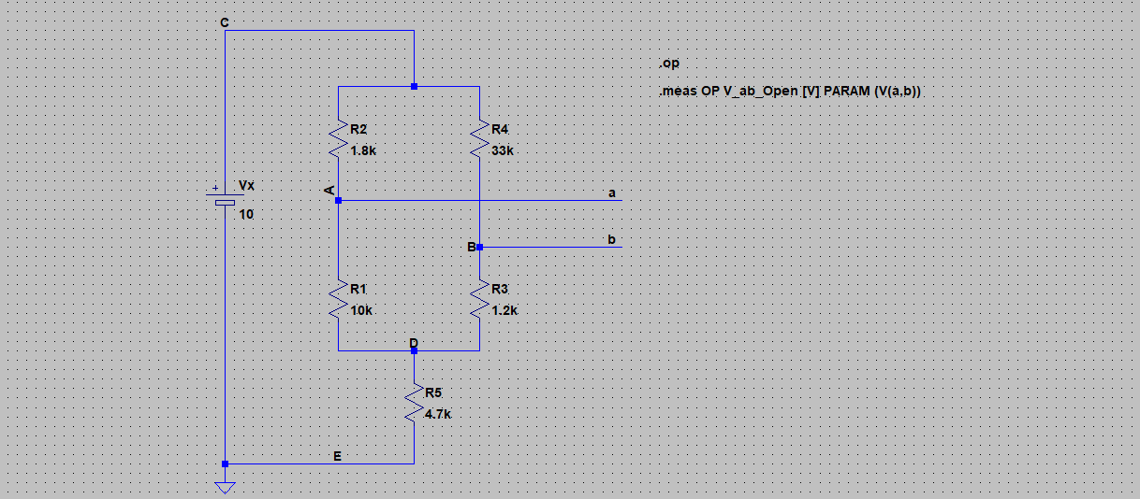

**Report Requirements**

* Include **Vth** voltage from Spice Error Log
* Fill out Table A.1

|  |  |
| --- | --- |
| **Table A.1 Thevenin Equivalent Voltage**  **Measurement Condition:** No loading resistor is connected | |
| **Thevenin Voltage:** Voltage across the A-B terminals | V th = VAB = |

**(A2) Thevenin Equivalent Resistance**

Run DC analysis of the following circuit to determine **Thevenin equivalent resistance**

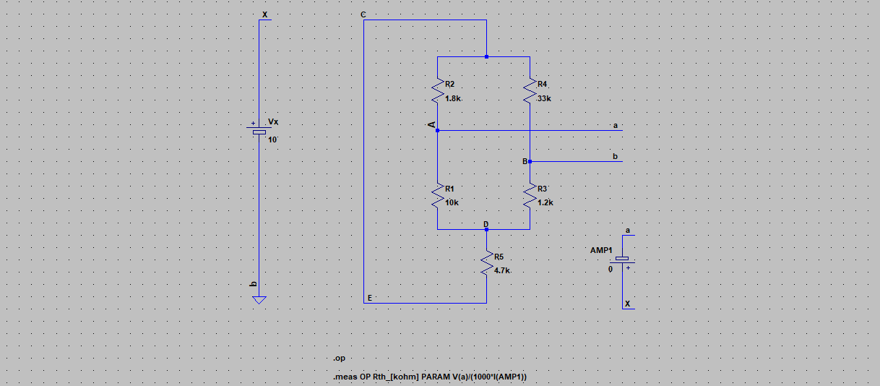

**Report Requirements**

* Include **Rth** resistor from Spice Error Log
* Fill out Table A.2

|  |  |
| --- | --- |
| **Table A.2 Thevenin Equivalent Resistor**  **Measurement Condition:** Remove voltage source (Vx),and short the remaining terminals | |
| **Thevenin Resistor:** Resistance between A-B terminals | Rth = RAB = |

**(A3) Load current of Original Network**

Run DC analysis of the following circuit to determine **load current** of **RL = 1kΩ**

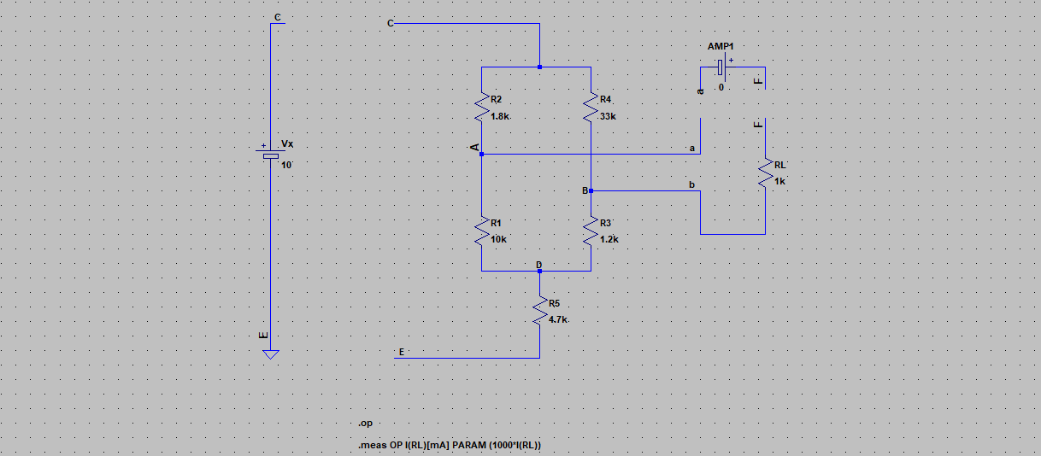

**Report Requirements**

* Include **IRL** current from Spice Error Log
* Fill out Table A.3

|  |  |
| --- | --- |
| **Table A.3 Load current for RL = 1kΩ**  **Measurement Condition:** Connect **RL = 1kΩ** resistor between A-B terminals | |
| **Load Current:** The current through **RL = 1kΩ** | IRL1 = |

**(A4) Thevenin Equivalent Circuit Test**

**Circuit Elements: as in section-A1 and A2**

Run DC analysis of the following circuit to determine **load current of RL = 1kΩ**

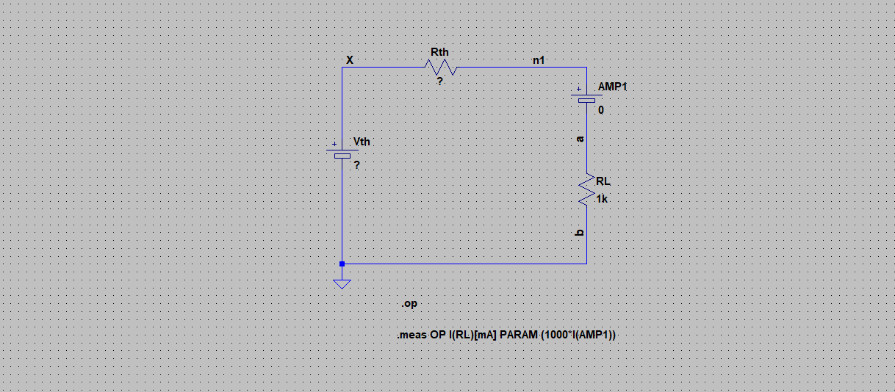

**Report Requirements**

* Include **IRL** current from Spice Error Log
* Fill out Table A.4
* Verify the theorem
* Include **date** and **time** from Spice Error Log

|  |  |
| --- | --- |
| **Table A.4 Load current for RL = 1kΩ**  **Measurement Condition:** Connect **RL = 1kΩ** resistor across Thevenin Equivalent | |
| **Load Current** of **RL = 1kΩ** in Thevenin Equivalent | IRLT = |
| **Verify the theorem:** Both Original Network and its Thevenin Equivalent should provide the same load current | IRL1 =? IRLT |

**C- Norton Equivalent**

Run DC analysis of the following circuit to determine **Norton equivalent current**

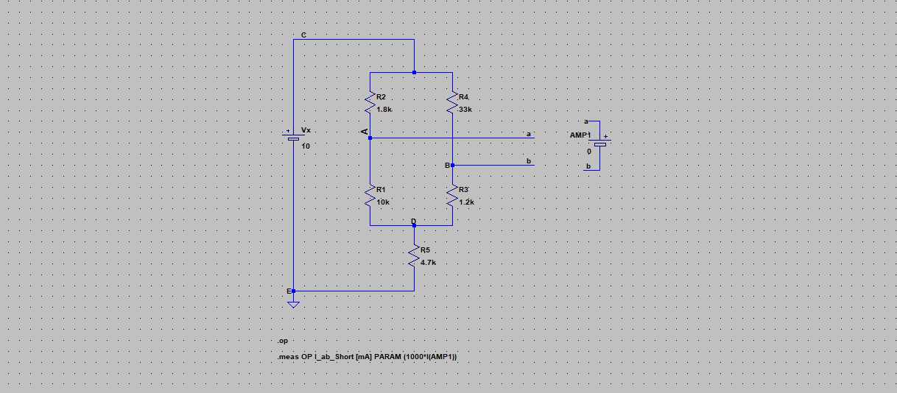

**Report Requirements**

* Include **IAB** current from Spice Error Log
* Fill out Table B.1.1 and B.1.2

|  |  |
| --- | --- |
| **Table B.1.1 Short current of (A-B) Terminals**  **Measurement Condition:** short A-B terminals | |
| **Short Current:** The current through ampermeter-AMP1 | IAB = |

|  |  |
| --- | --- |
| **Table B.1.2 Norton Elements** | |
| **Norton Current:** Current through the shorted A-B terminals | I NT = IAB = |
| **Norton Resistor:** Resistance between A-B terminals as in section-A2 | RNT = RAB = kΩ |

**D- Norton Equivalent Network Test**

**Circuit and Elements: as in section-C**

Run DC analysis of the following circuit to determine load current of **RL = 1kΩ**

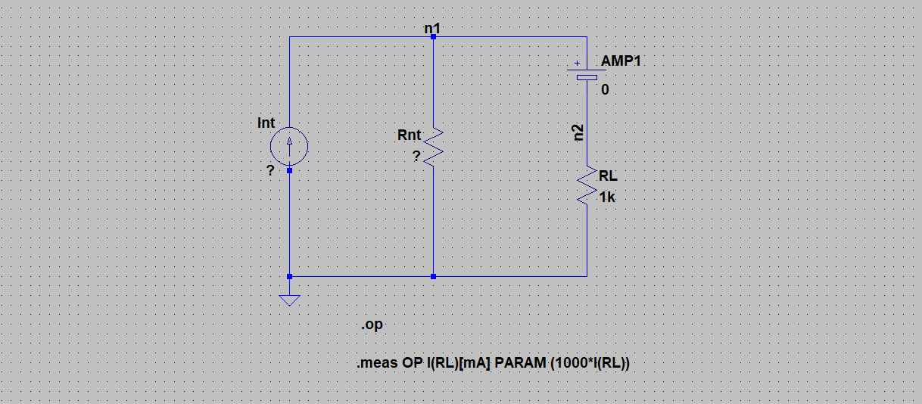

**Report Requirements**

* Include **IRL** current from Spice Error Log
* Fill out Table D.1
* Verify the theorem
* Include **date** and **time** from Spice Error Log

|  |  |
| --- | --- |
| **Table D.1 Load current for RL = 1kΩ**  **Measurement Condition:** Connect **RL = 1kΩ** resistor across the Norton Equivalent | |
| **Load Current** of **RL = 1kΩ** in **Norton Equivalent** | IRLN = |
| **Load Current** of **RL = 1kΩ** in **Original Network** as in section-A3 | IRL1 = |
| **Verify the theorem:** Both Original Network and its Norton Equivalent should provide the same load current | IRLN =? IRL1 |

**E- Maximum Power Transfer Test**

Run DC analysis of the following circuit to determine **load power**

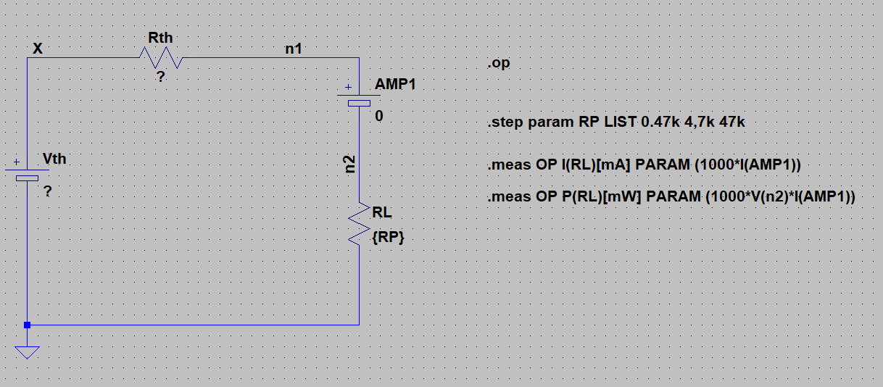

**Report Requirements**

* Include the power **PRL** from Spice Error Log
* Fill out Table E.1
* Determine **optimum** power transfer resistor
* Include **date** and **time** from Spice Error Log

|  |  |  |  |  |  |  |
| --- | --- | --- | --- | --- | --- | --- |
| **Table E.1 Max Power Transfer** | | | | | | |
| **Load resistant ↓** | **Measurement** | | |  | | |
|  | **IRL [mA]** | **VRL [V]** | **PRL [mW]** |  |  |  |
| **RL =0.1*RTH** |  |  |  |  |  |  |
| **RL = RTH** |  |  |  |  |  |  |
| **RL = 10*RTH** |  |  |  |  |  |  |
|  | **Optimum RL** = k Ω | | | | | |

**References**

[1] Basics of Electrical Circuits Lab Manual, ITU, online, 2013.

**Please report any error to** [**ozayan@itu.edu.tr**](mailto:ozayan@itu.edu.tr) **[R2021.1, Ayan Derya]**